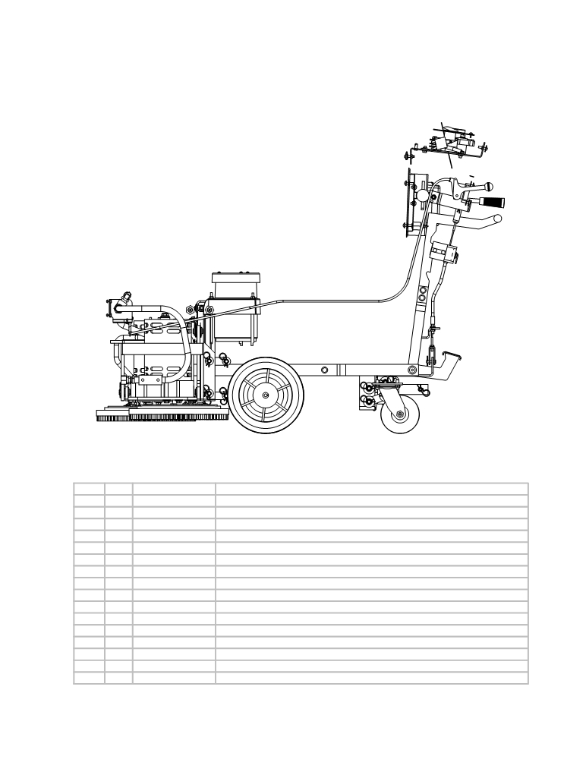

VIEW OF SCRUBBER PARTS WITH MAJOR PLASTIC PARTS, MAINFRAME, AND VACUUM HOSES REMOVED
(VIEWS THAT SHOW LISTED PARTS
ARE ON FOLLOWING PAGES)

 | ITEM | SKU | Description | QTY
 | 1 | E11325 | 16" pad driver | 2
 | 2a | E11335 | 10"x2 1/2" PERF. RUBBER WHEEL | 2
 | 2b | E11631 | 10"x2 1/2" Transaxle Wheel | 2
 | 3 | E11629 | 5"x2" PERF. WHEEL w/SEALED | 2
 | 4 | E81080 | Bolt 3/8-16x3/4 | 8
 | 5 | E81066 | Washer, 3/8" Split Lock, Zinc | 8
 | 6 | AS26/321149 | Speed Control Mount | 1
 | 7 | E10807 | 36-VOLT - AMP SOLO CONTROL | 1
 | 8 | E10008 | SPEED CONTROL BRACKET | 1
 | 9 | E11890 | ELECTRICAL PANEL | 1
 | 10 | E11177 | 1/4 NUT WING | 5
 | 11 | E81865 | Rod, Treaded 1/4-20 x 9-3/4 | 3
 | 12 | AS26/32302 | Brass stud | 2
 | 13 | E11730 | INSULATOR GLASTIC | 2
 | 14 | E11085 | 1/4-20 FLANGED NUT | 2
 | 15 | E83570 | Screw 1/4" - 20 x 1" | 2

ITEM QTY. PART NO. DESCRIPTION
1 2 AS26801 Pad Holder (please note that scrub and strip brushes are available)
2a 2 AS261382 10" Wheel (for Brush Drive only)
2b 2 AS26/321383 10" Wheel (for Traction Drive only)
3 2 AS26/321380 5" Swival Caster
4 8 AS26/32210 Bolt
5 8 AS26/32292 Lock Washer
6 1 AS26/321149 Speed Control Mount (Traction Drive Only)
7 1 AS261600 Speed Control (Traction Drive Only)
8 1 AS26/321150 Speed Control Bracket (Traction Drive Only)
9 1 AS26/321108 Electrical Panel
10 5 AS26/32246 Wingnut
11 3 AS26/32317 Threaded rod
12 2 AS26/32302 Brass stud
13 2 AS26/32800 Terminal block
14 2 AS26/32232 Flanged nut
15 2 AS26/32261 Screw

